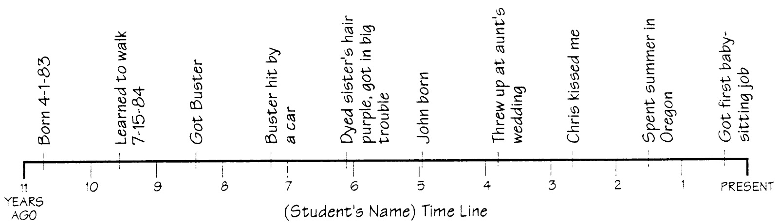

General Timeline Example (below) and Student Timeline Example (above)

